Abbygail Martinez

CIS2321

12 November, 2026

System Requirements Document (SRD): Sideways Elevator Panel

Executive Summary
The proposed system is an enhanced elevator panel and control system that supports sideways (horizontal) movement in addition to traditional vertical travel. The new design will improve building accessibility, allow more flexible floor plans, and provide a modern user experience for building occupants.

System Requirements

Functional Requirements
- The system must move elevator cars both vertically and horizontally.
- The elevator panel must allow users to select both floor and direction (up, down, left, right).
- The system must display current location and destination on the panel.
- The system must stop precisely at selected destinations.
- The panel must provide visual and audio feedback for all user actions.

User Interactions
- Users will interact with the panel by pressing floor and direction buttons.
- The panel will have indicator lights to confirm selections.
- Emergency stop and alarm buttons will be included.
- The panel will display error or status messages as needed.

Performance Requirements
- The elevator must respond to user input within 2 seconds.
- The system must operate reliably with minimal downtime.
- Safety systems must activate immediately if a fault is detected.

Safety Considerations
- The system must include emergency brakes and alarms.
- All movement paths must have safety sensors to prevent accidents.
- The system must comply with all local and national elevator safety codes.

Design Constraints
- The panel must fit within standard elevator car dimensions.
- The system must operate in existing elevator shafts or designated new shafts.
- All controls must be accessible for users with disabilities.
- The system must use hardware and software approved for elevator controls.

Schedule and Budget
- Estimated Timeline:
  - Requirements & Design: 1 month
  - Prototype Development: 2 months
  - Testing & Safety Certification: 2 months
  - Installation: 1 month
- High-Level Costs:
  - Hardware (panels, motors, sensors)
  - Software development
  - Installation and testing
  - Staff training
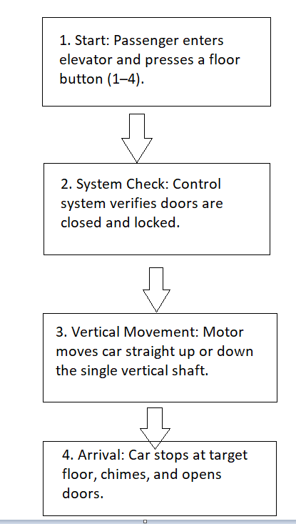
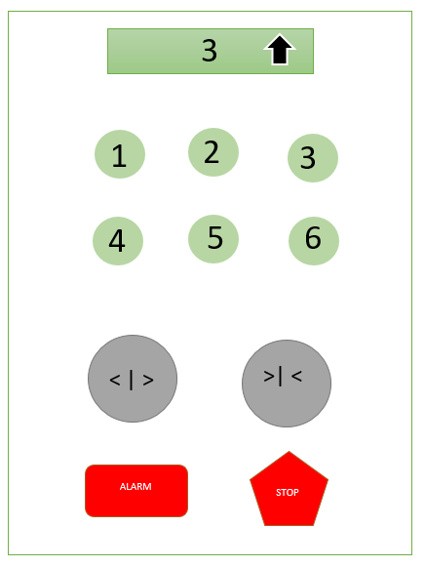
Current System Diagram

Proposed System Diagram and Flowchart


